附件4

一、报名表

考生报名登记表

**报名岗位代码 \*\*\*\***

|  |  |  |  |  |  |  |  |  |  |  |  |  |  |  |  |  |  |  |
| --- | --- | --- | --- | --- | --- | --- | --- | --- | --- | --- | --- | --- | --- | --- | --- | --- | --- | --- |
| **姓名** | | 张三 | | **性别** | 男 | **民族** | 汉 | **出生日期** | 1991.1.1 | | | **籍贯** | | | | 安徽省 |  | |
| **户籍** | | 马鞍山市 | | **住地** | **马鞍山市XX小区** | | | **婚姻状况** | 已婚 | | | **政治面貌** | | | | 群众 |
| **身份证号** | | | | |  | | | **联系电话** | **XXX** | | | **身高** | | | | **XXCM** |
| **最高学历** | | | | | **本科** | | | **专业** | XX | | | **职称** | | | | XX |
| **毕业院校** | | | | | XX | | | **毕业日期** | XX | | **紧急联系人 联系方式** | | | **XX** | | |
| **主要学习简历** | **起止年月** | | | | **就读院校** | | | | | | | | **所学专业** | | | | **证书名称** | |
| 2010.9-2014.7 | | | | XX | | | | | | | | XX | | | | XX | |
|  | | | |  | | | | | | | |  | | | |  | |
|  | | | |  | | | | | | | |  | | | |  | |
| **工作经历** | **起止年月** | | | | **工作单位** | | | | | | | | **部门/职位** | | | | | |
| 2014.7-2015.6 | | | | XX | | | | | | | | XX | | | | | |
|  | | | |  | | | | | | | |  | | | | | |
|  | | | |  | | | | | | | |  | | | | | |
| **家庭主要成员及社会关系** | **姓名** | | **与本人关系** | | **工作单位** | | | | | | | | **部门/职位** | | | | | |
| 张X | | 父子 | | XX | | | | | | | | XX/yy | | | | | |
|  | |  | |  | | | | | | | |  | | | | | |
|  | |  | |  | | | | | | | |  | | | | | |
| **是否有亲属在横望集团工作** | | | □是 （姓名 部门 职务 ） ☑否 | | | | | | | | | | | | | | | |
| **个人简介** | | | **XXXXXXXXXX** | | | | | | | | | | | | | | | |
|
| **通信地址** | | | XXX | | | | | | **邮编** | XX | | | | | **电子邮箱** | | | XXX |
| **本人承诺** | **本人承诺以上填写内容全部真实有效**  **承诺人（签名）：张三（手写）**  **2021 年8 月 X 日** | | | | | | | | | | | | | | | | | |

二**、身份证原件正反面扫描件/照片**

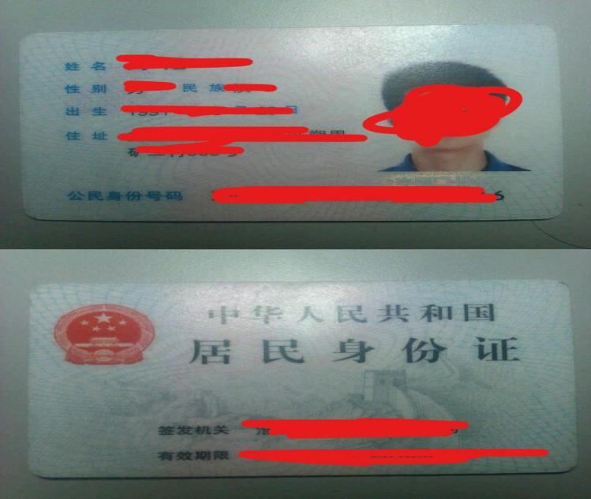

**三、学历证书、学位证书原件扫描件/照片**

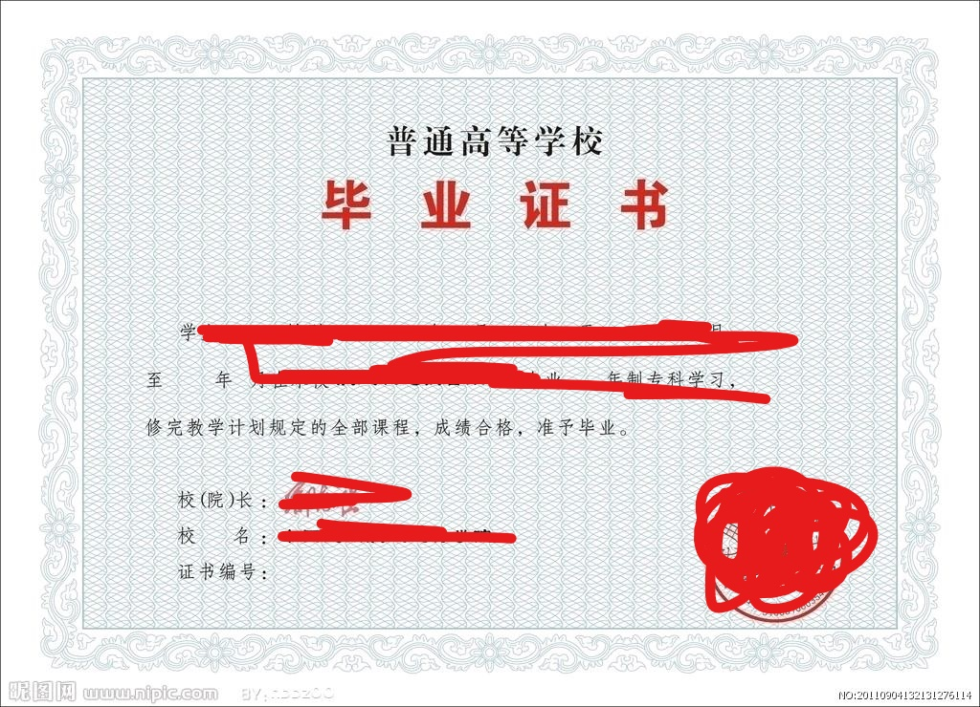

**四、专业技术资格证书、国家注册资格证书、奖励证书扫描件/照片**

**（图略）**

**五、个人详细简历**

**（图略）**

**六、工作证明**

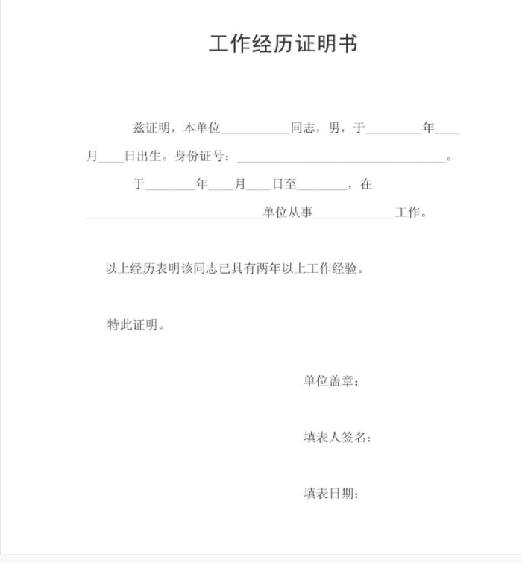

**七、报考诚信承诺书**

